Agenda

Agile & Scrum Framework

Agile – Is a software development Methodology.

4 Manifesto of Agile

**Individuals and interactions** over processes and tools  
**Working software** over comprehensive documentation  
**Customer collaboration** over contract negotiation  
**Responding to change** over following a plan

12 Principles

**Principles behind the Agile Manifesto**

*We follow these principles:*

Our highest priority is to satisfy the customer  
through early and continuous delivery  
of valuable software.

Welcome changing requirements, even late in  
development. Agile processes harness change for  
the customer's competitive advantage.

Deliver working software frequently, from a  
couple of weeks to a couple of months, with a  
preference to the shorter timescale.

Business people and developers must work  
together daily throughout the project.

Build projects around motivated individuals.  
Give them the environment and support they need,  
and trust them to get the job done.

The most efficient and effective method of  
conveying information to and within a development  
team is face-to-face conversation.

Working software is the primary measure of progress.

Agile processes promote sustainable development.  
The sponsors, developers, and users should be able  
to maintain a constant pace indefinitely.

Continuous attention to technical excellence  
and good design enhances agility.

Simplicity--the art of maximizing the amount  
of work not done--is essential.

The best architectures, requirements, and designs  
emerge from self-organizing teams.

At regular intervals, the team reflects on how  
to become more effective, then tunes and adjusts  
its behavior accordingly.

In Agile,

3 Ceremonies [Daily Standup, Sprint Planning, Sprint Review & Retro]

3 Questions in Daily Standup [ What was done, What will you do today, roadblocks]

3 Documents in Agile [ Product Backlog (epic, user stories, requirements), Sprint Backlog, Breakdown Chart]

Requirements Priority [ High, medium, low]

Work/effort Estimation [ t-shirt sizing small, medium, large, extra-large, 1,2,3,5..]

3 Roles in Agile [Product Owner, Scrum Master, Scrum Member]

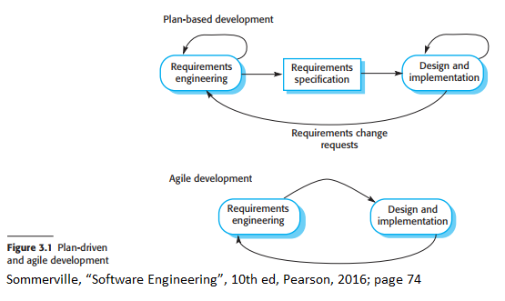

Real – Life example:

Cooking –

You cook everything, then clean vessels. [Regular SDLC]

You cook and clean immediately without waiting for the cooking process to complete. [ Agile approach]

Epic – I need a Facebook clone

Login Form (User Stories) – As a ____, I want to ____, so that _______

Profile Page

Post form

Display post

Friends details

Settings

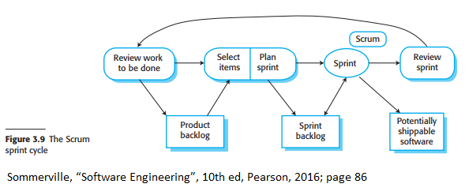

Sprint Review/Retro

1. What to start (What we need to add)
2. What to Stop (what went wrong)
3. What to continue (What went well)

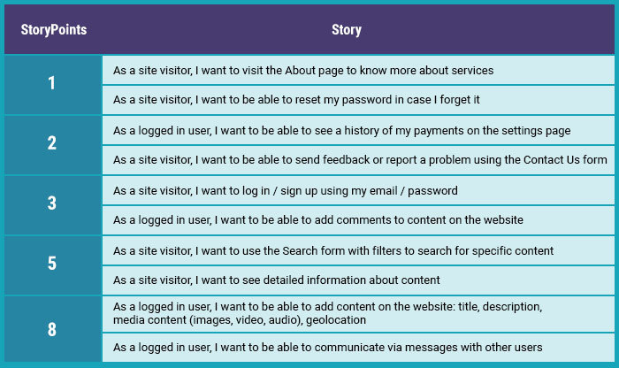

Ceremonies

1)Sprint Planning (At the beginning of each sprint- only one time for a sprint)

2)Sprint Review (At the end of each sprint – only one time for a sprint)

3)Sprint Retro (At the end of each sprint – Only one time for a sprint)

4) Daily Standup (Happens every day updating what was done, what will be the plan for today, roadblocks)